CO-3 ASSESSMENT -2
11. ChromaDB-Based Document QA
Aim
To develop a Document Question Answering system using ChromaDB by storing document chunks and retrieving relevant information for each user query.
Introduction
Document Question Answering is a system that allows users to ask questions about the information contained in a document. In this project, ChromaDB is used as a vector database to store document chunks and retrieve the most relevant chunks for a given question.
The system reads a document, divides it into smaller chunks, stores the chunks in ChromaDB, and searches for relevant information when the user enters a question.
Objectives
- To create a document-based question-answering system.
- To divide a document into smaller chunks.
- To store document chunks in ChromaDB.
- To retrieve relevant chunks for user queries.
- To provide useful information from the supplied document.

Algorithm
- Step 1: Start the program.
- Step 2: Import the ChromaDB library.
- Step 3: Create a ChromaDB client and collection.
- Step 4: Read the input document.
- Step 5: Split the document into smaller chunks.
- Step 6: Store the chunks in ChromaDB.
- Step 7: Accept a question from the user.
- Step 8: Search ChromaDB for relevant chunks.
- Step 9: Display the retrieved information.
- Step 10: Stop the program.
Code
import chromadb
# Create ChromaDB client
client = chromadb.Client()
# Create collection
collection = client.create_collection(name="documents")
# Read the document
with open("document.txt", "r", encoding="utf-8") as file:
text = file.read()
# Split document into chunks
chunks = [chunk.strip() for chunk in text.split("\n\n") if chunk.strip()]
# Store chunks in ChromaDB
collection.add(
documents=chunks,
ids=[str(i) for i in range(len(chunks))]
)
print("Document stored successfully!")
print("Number of chunks:", len(chunks))
# Ask question
question = input("\nEnter your question: ")
# Search ChromaDB
results = collection.query(
query_texts=[question],
n_results=2
)
# Display results
print("\nRelevant information:\n")
for result in results["documents"][0]:
print(result)
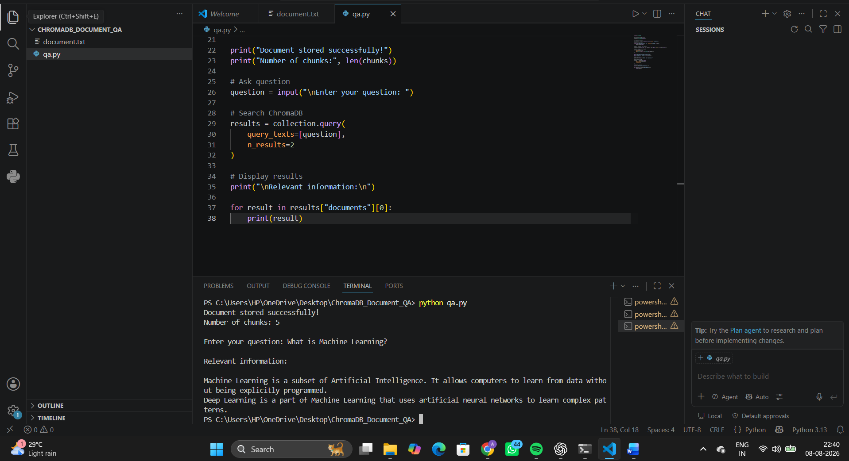
Result
The Hospital Information Document QA system was successfully developed using ChromaDB. The system stored hospital document chunks and retrieved relevant information based on user questions.
Conclusion
The developed system demonstrates how RAG and ChromaDB can be used for document-based question answering. Hospital information such as departments, services, timings, appointments, emergency procedures, and admission procedures can be retrieved efficiently from the supplied document.
The system provides document-based responses and avoids depending on unrelated external information.

19. Hospital Information Document QA Using RAG
Aim
To develop a Retrieval-Augmented Generation (RAG) based Hospital Information Document Question Answering system using ChromaDB to retrieve relevant information about hospital departments, services, timings, and procedures.
Introduction
A Hospital Information Document QA system allows users to ask questions about the information available in a hospital document. The system uses ChromaDB to store document chunks and retrieve the most relevant information for a user's question.
The system follows the RAG approach by retrieving information from the supplied hospital document before displaying the answer. Therefore, the responses are based only on the information available in the document.
Objectives
- To create a hospital information document.
- To divide the document into smaller chunks.
- To store the chunks in ChromaDB.
- To retrieve relevant information for user queries.
- To answer questions about hospital departments and services.
- To provide information about timings and procedures.
- To restrict answers to the supplied document.

Algorithm
Step 1: Start the program.
Step 2: Import the ChromaDB library.
Step 3: Create a ChromaDB client and collection.
Step 4: Read the hospital information document.
Step 5: Divide the document into smaller chunks.
Step 6: Store the document chunks in ChromaDB.
Step 7: Accept a question from the user.
Step 8: Search ChromaDB for relevant document chunks.
Step 9: Retrieve the most relevant information.
Step 10: Display the retrieved information to the user.
Step 11: Stop the program.
Code
import chromadb
# Create ChromaDB client
client = chromadb.Client()
# Create collection
collection = client.create_collection(name="hospital_information")
# Read hospital document
with open("hospital.txt", "r", encoding="utf-8") as file:
text = file.read()
# Split document into chunks
chunks = [chunk.strip() for chunk in text.split("\n\n") if chunk.strip()]
# Store chunks in ChromaDB
collection.add(
documents=chunks,
ids=[str(i) for i in range(len(chunks))]
)
print("Hospital document stored successfully!")
print("Number of chunks:", len(chunks))
# Ask question
question = input("\nEnter your hospital question: ")
# Search ChromaDB
results = collection.query(
query_texts=[question],
n_results=2
)
# Display relevant information
print("\nRelevant information:\n")
for result in results["documents"][0]:
print(result)

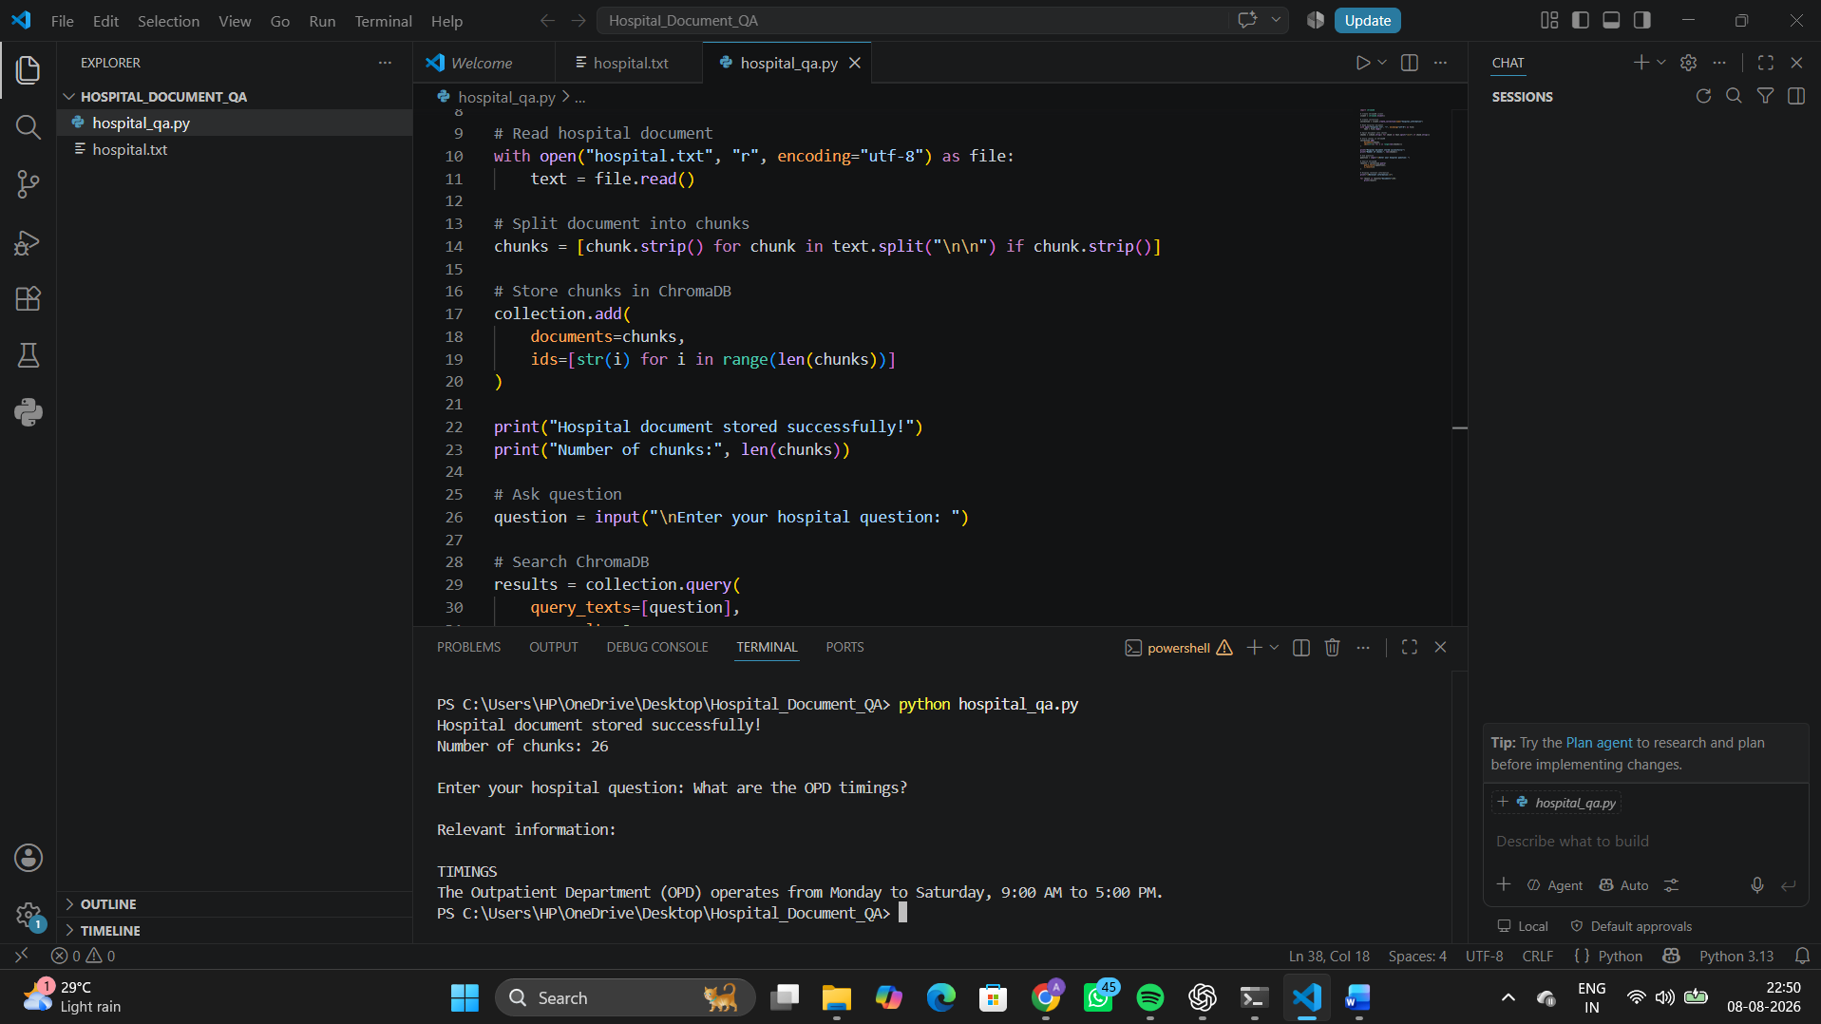
Result
The Hospital Information Document QA system was successfully developed using ChromaDB. The system stored hospital document chunks and retrieved relevant information based on user questions.
Conclusion
The developed system demonstrates how RAG and ChromaDB can be used for document-based question answering. Hospital information such as departments, services, timings, appointments, emergency procedures, and admission procedures can be retrieved efficiently from the supplied document.
The system provides document-based responses and avoids depending on unrelated external information.

